

**FIT MOVES**



**CERTIFICATE**

This is to certify that the students

* **Sharjeel Khan**  Student 1551315
* **Husnain Ghouri** Student 1551321
* **Touqeer Bangash** Student 1551072
* **Yogesh Matlani** Student 1553315

Of batch **PR2-202401C1** have succesfully completed given task for the topic

**FACULTY: SIR FAIZ**

**SEMESTER CPISM**

**APTECH LEARNING**

**SHAHRAH-E-FAISAL**

**ACKNOWLEDGE**

The thirst for learning, upgrading technical skills and applying the concepts in real life environment at a fast pace is what the industry demands from IT professionals today. However busy work schedules, far-flung locations, unavailability of convenient time-slots pose as major barriers when it comes to applying the concepts into realism. And hence the need to look out for alternative means of implementation in the form of laddered approach. The above truly pose as constraints especially for our students too! With their busy schedules, it is indeed difficult for our students to keep up with the genuine and constant need for integrated application which can be seen live especially so in the field of IT education where technology can change on the spur of a moment. Well, technology does come to our rescue at such times!! Keeping the above in mind and in tune with our constant endeavor to use technology in our training model, we at Aptech have thought of revolutionizing the way our students learn and implement the concepts using tools themselves by providing a live and synchronous e-Project learning environment!

**So, what is the**

**E-project**

E-Project is a step-by-step learning environment that closely simulates the classroom and Lab based learning environment into actual implementation. It is a project implementation at your fingertips!! An electronic, live juncture on the machine that allows you to

• Practice step by step i.e., laddered approach.

• Build a larger more robust application.

• Usage of certain utilities in applications designed by user.

• Single program to unified code leading to a complete application.

• Learn implementation of concepts in a phased manner.

• Enhance skills and add value. • Work on real life projects.

• Give a real-life scenario and help to create applications more complicated and useful.

• Mentoring through email support.

**FIT MOVES**



Welcome to our website, where your health and well-being are our top priorities. Our mission is to provide comprehensive, compassionate care that meets the diverse needs of our community. With a team of dedicated healthcare professionals, we are committed to delivering personalized medical services using the latest advancements in medical technology.

**PROBLEM STATEMENT**

Aerobic exercise provides cardiovascular conditioning. The term aerobic actually means & quote; with oxygen, & quote; which means that breathing controls the amount of oxygen that can make it to the muscles to help them burn fuel and move. Although mankind has entered an era of well advanced hi-tech medical facilities which makes life more comfortable, the expected quality of life still seems to be far from reality. Problems like stress, anxiety, restlessness, nervous breakdown, other stress related ailments, fatigue breaking up of families, suicides are all on an exponential rise. The frustrated patients are now moving towards alternative non-scientific therapies for a better living. Aerobics with its multifold advantages, is gaining popularity in all parts of the world. For a common man aerobic is a fashion for keeping himself healthy and fit. While for some others it’s a boon for developing their concentration, memory and creativity.

‘Healthy mind’ is a group which is looking for developing a website which will host the A-to-Z information about aerobics and meditation. You have been approached develop the same with following requirements specification.

**USER MANUAL**

**HOME PAGE**

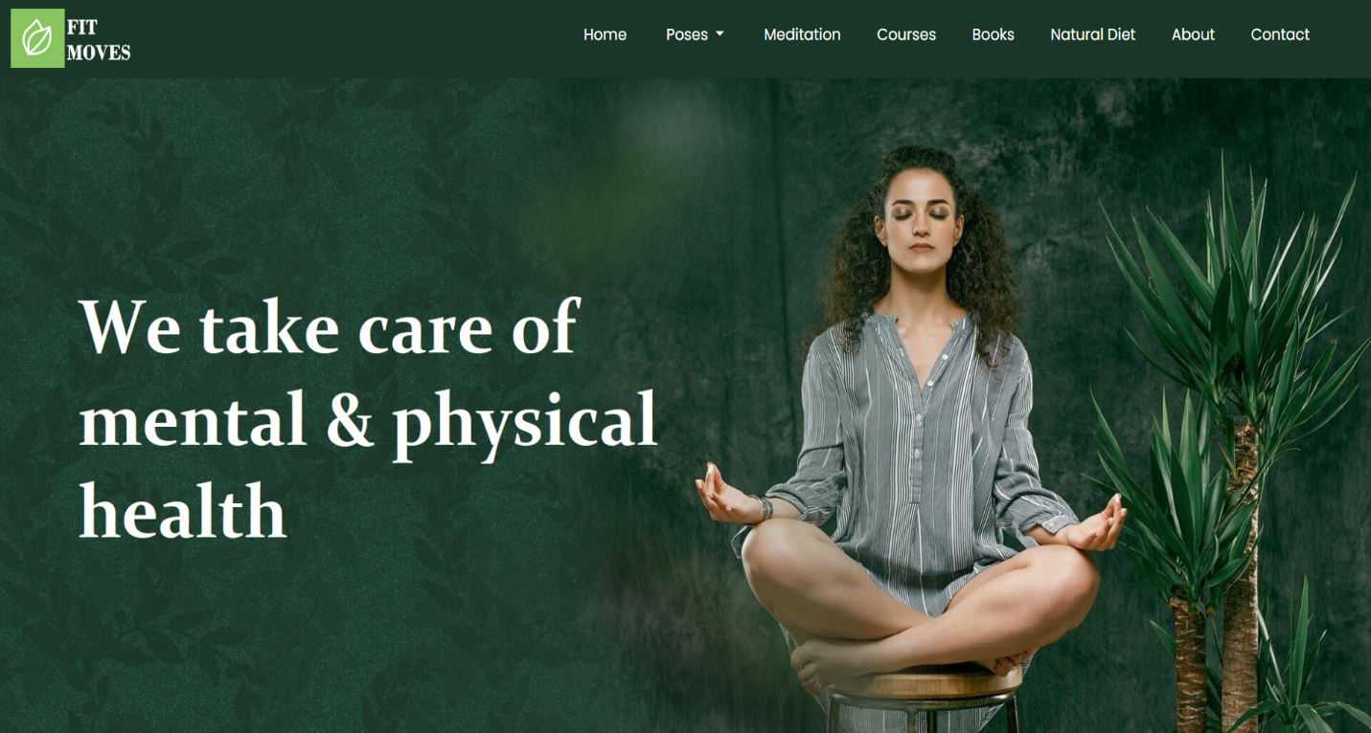



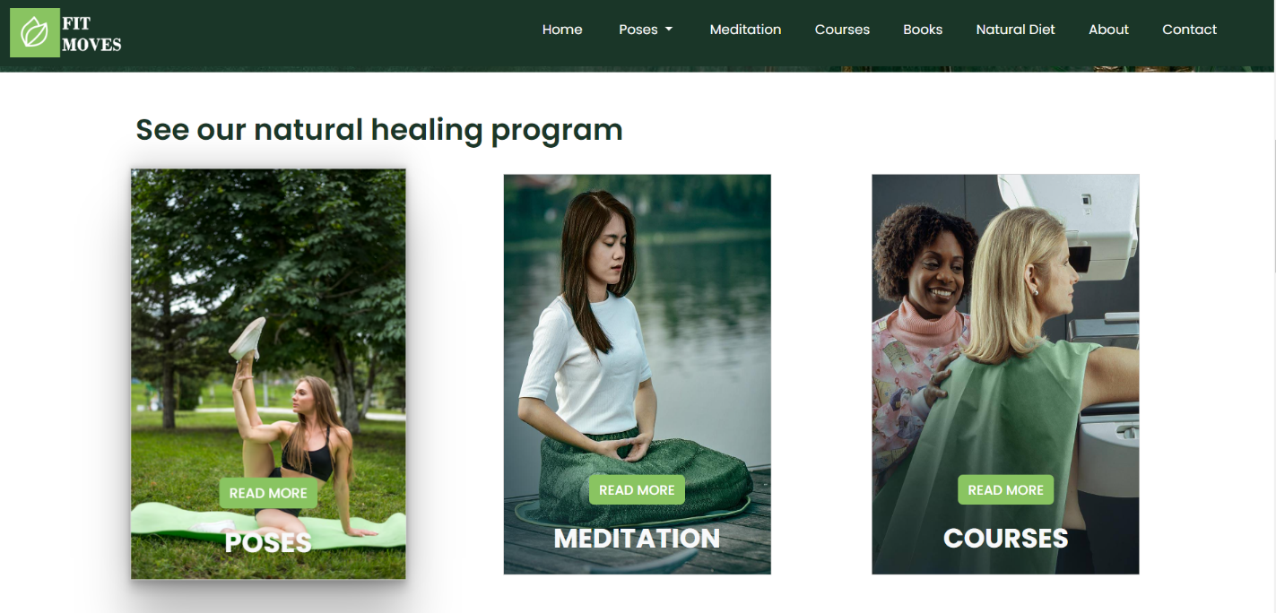

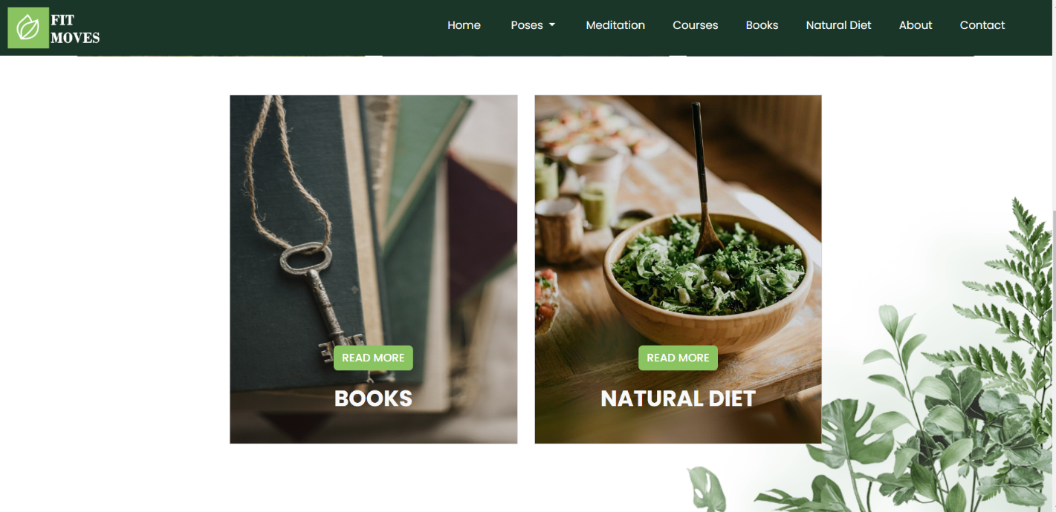

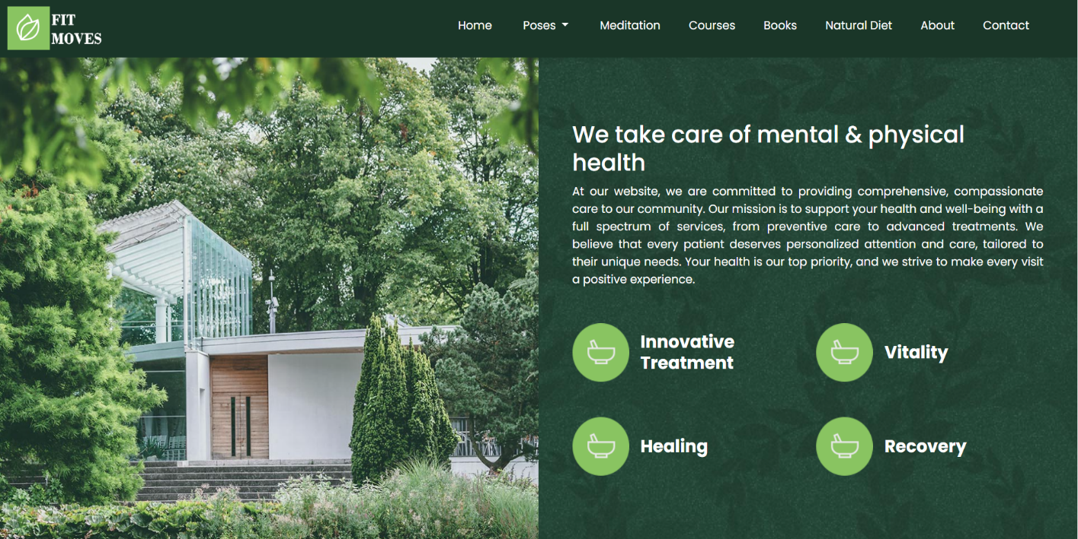

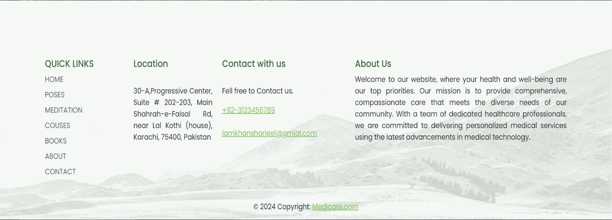

* This is the Home Page of our website which includes a navbar with main dropdown containing four poses’ categories, a programs section, a banner for making home page attractive and a footer.

**How** **to use home page:**

Basically home page is divided into:

* Header section which includes navbar and banner.
* Banner section.
* Footer.

**NAV BAR**



Navbar includes links of: -

1. Home
2. Pose
3. Meditation
4. Courses
5. Books
6. Natural diet
7. About
8. Contact

Dropdown includes links of: -

1. Poses by Types
2. Poses by Benefits
3. Poses General
4. Poses by Anatomy

**PROGRAMS SECTION**

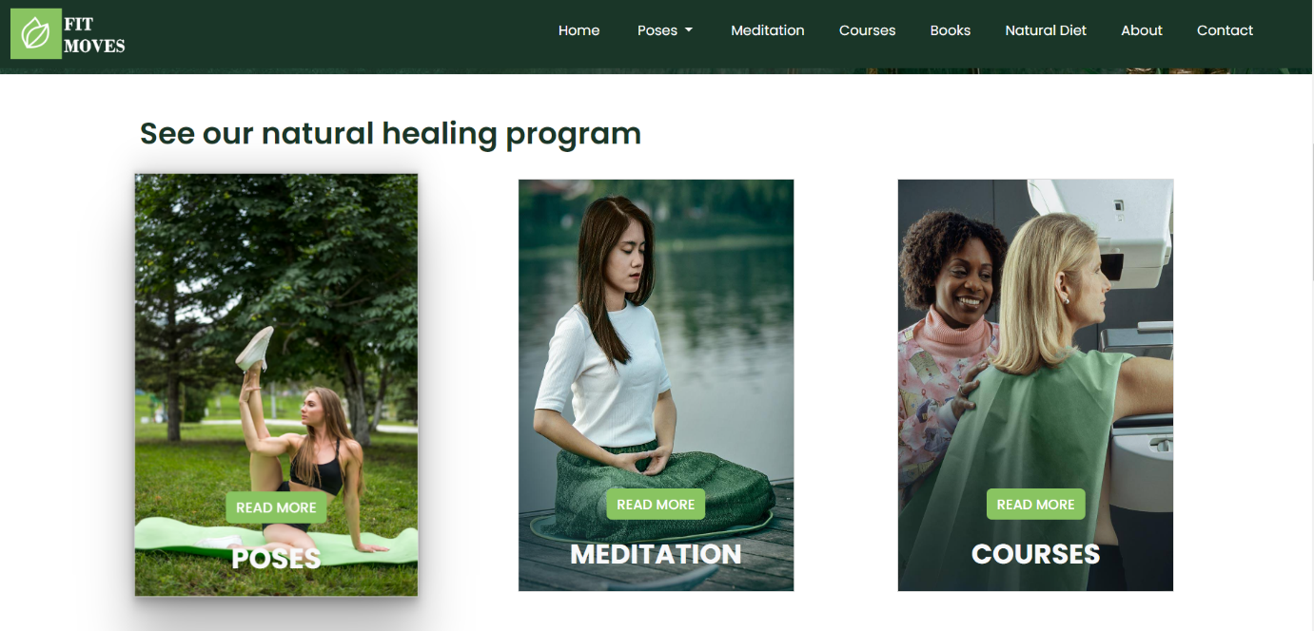



Program section includes: -

1. Linked Poses card
2. Linked Meditation card
3. Linked Courses card
4. Linked Books card
5. Linked Natural diet card

**FOOTER**

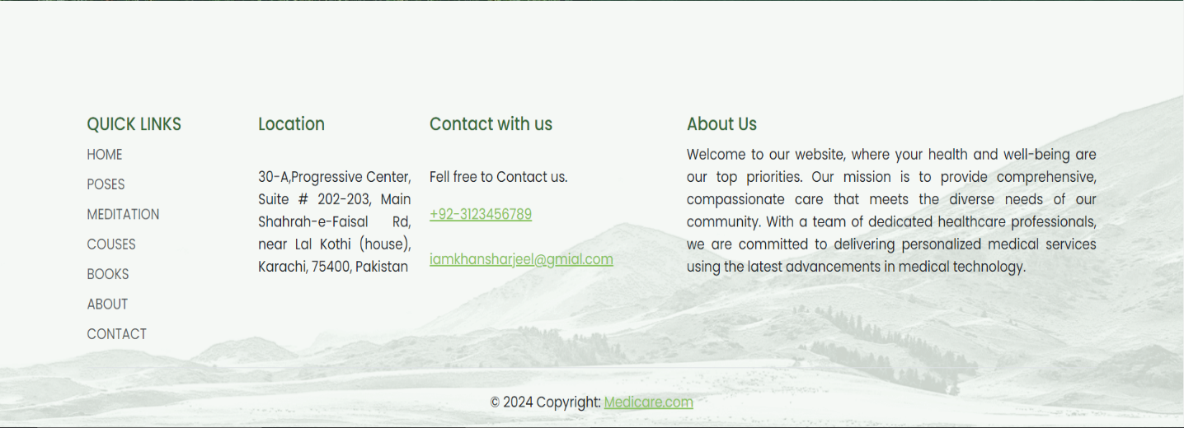

Footer includes quick links of: -

1. HOME
2. POSES
3. MEDITATION
4. COUSES
5. BOOKS
6. NATURAL DIET
7. ABOUT
8. CONTACT

**Screenshots of Home page**

**Navbar**

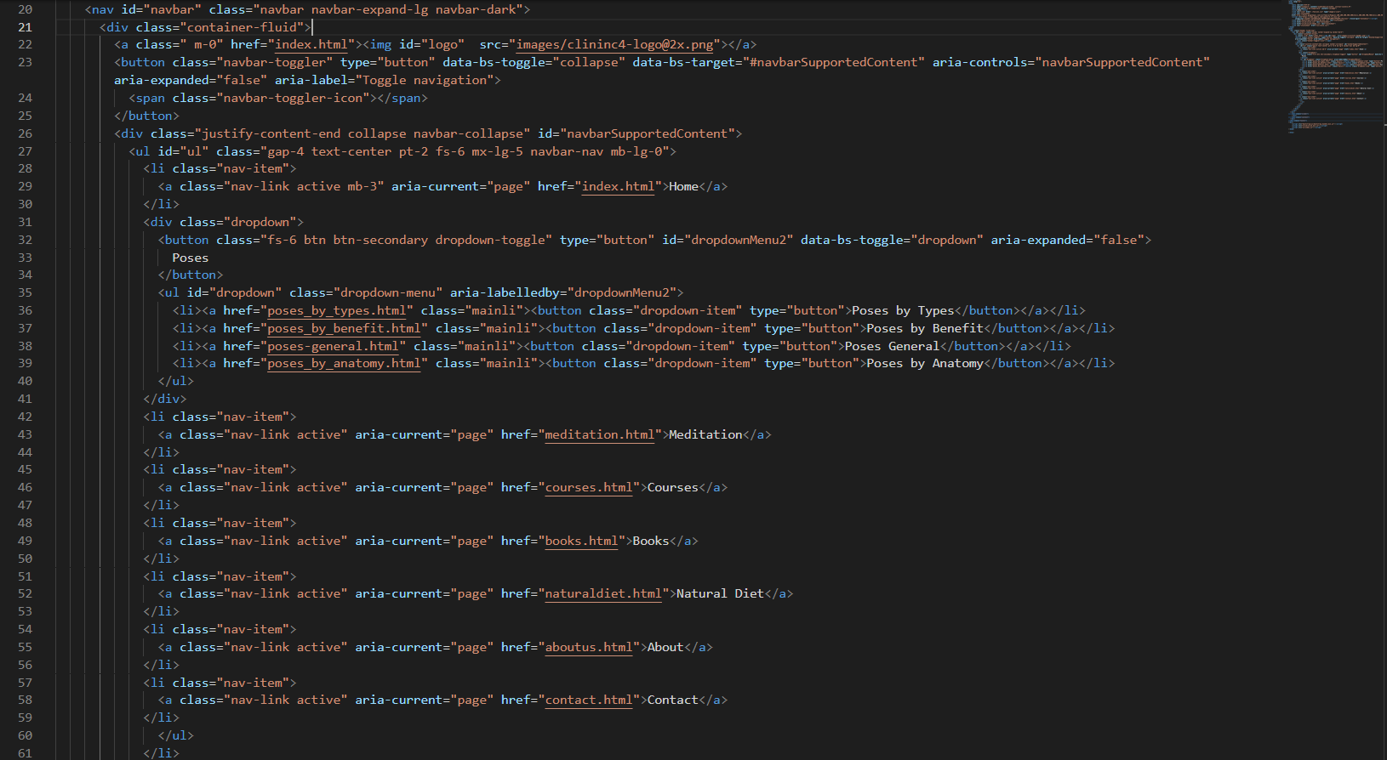

**PROGRAM SECTION CARDS**

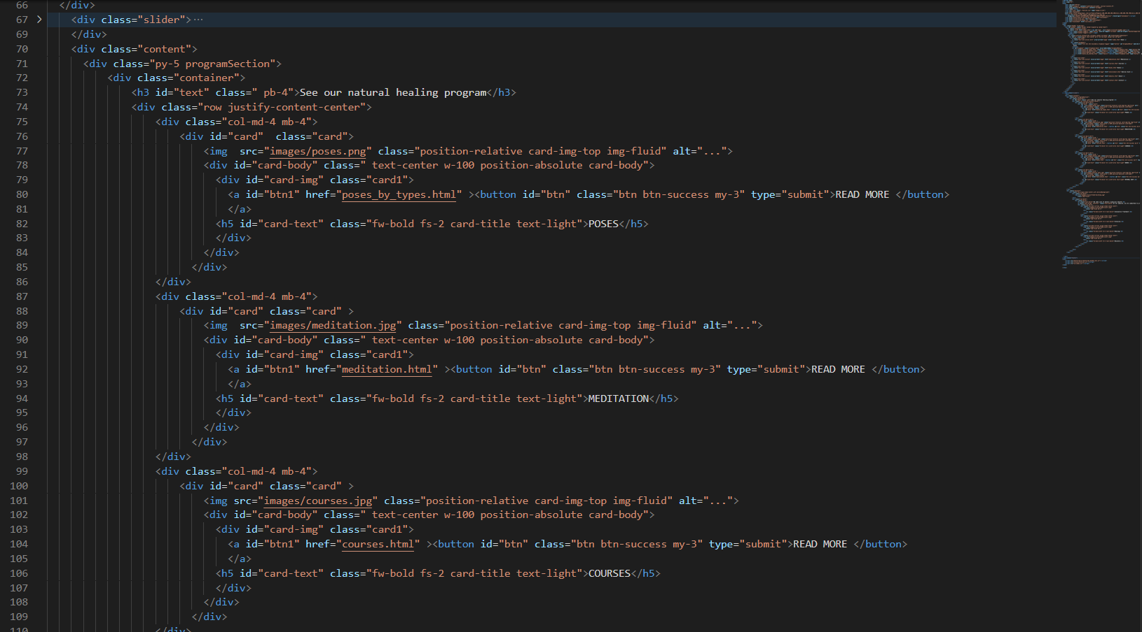

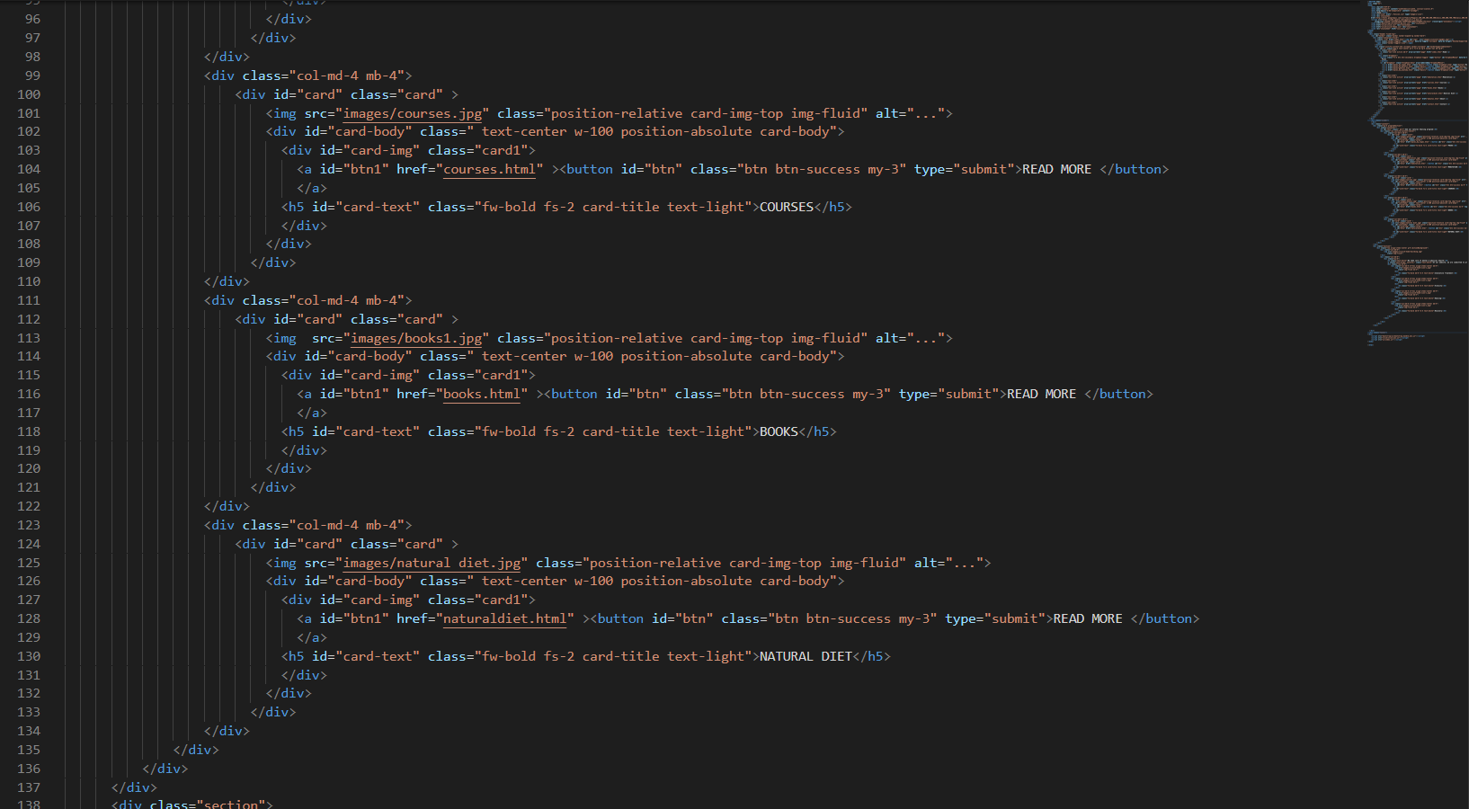

**FOOTER**

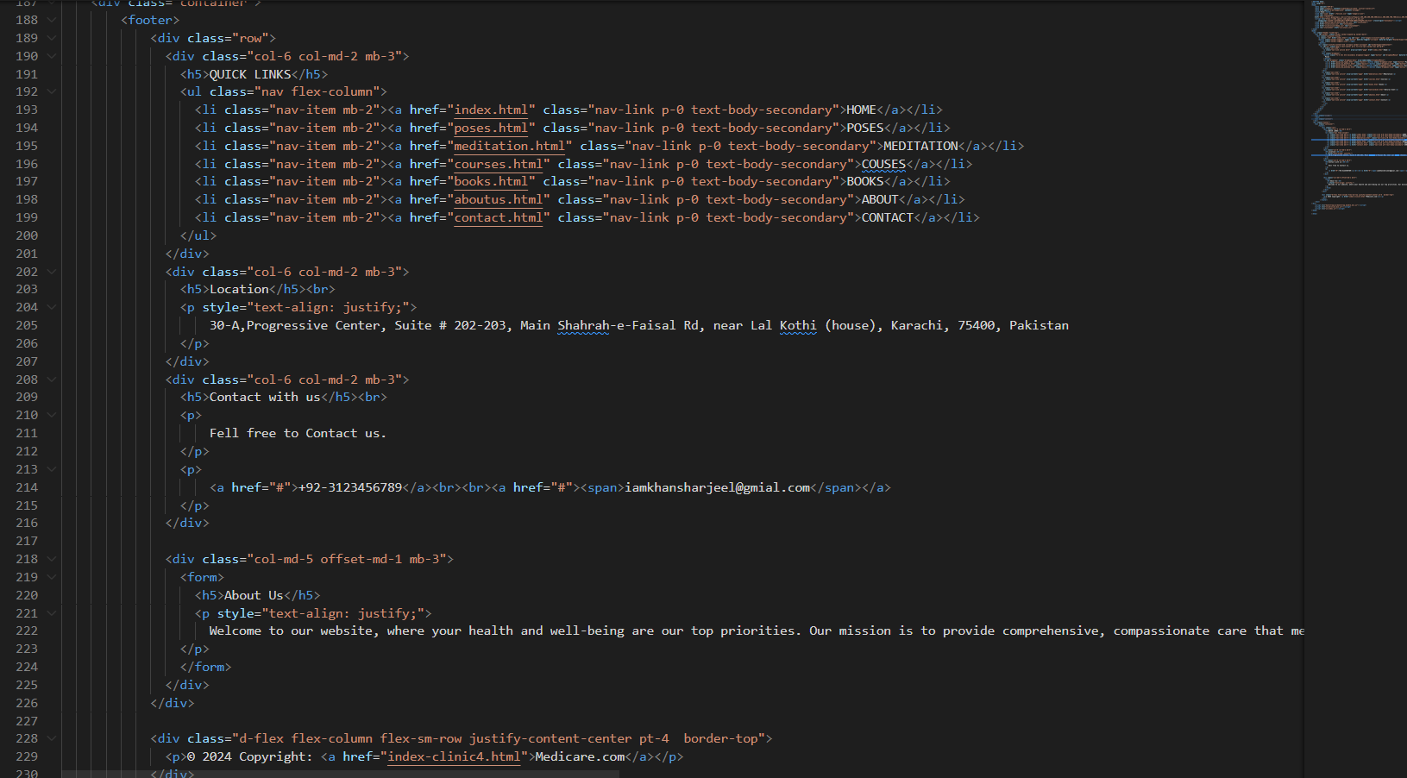

**POSES SECTION**

**POSES BY TYPES**

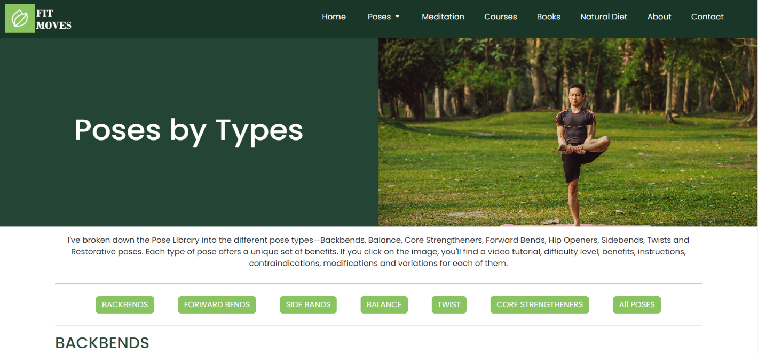

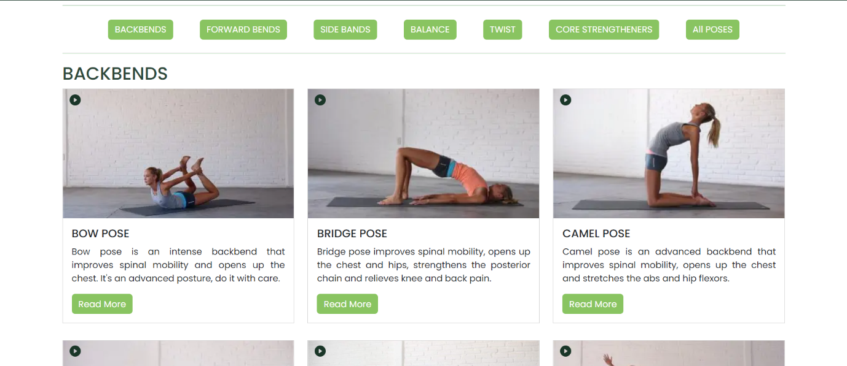

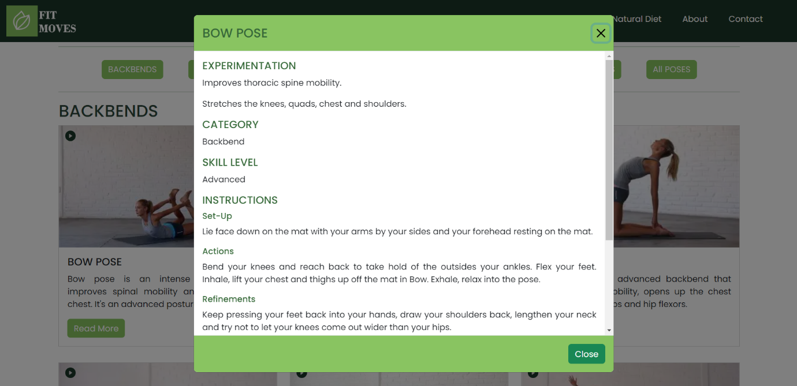

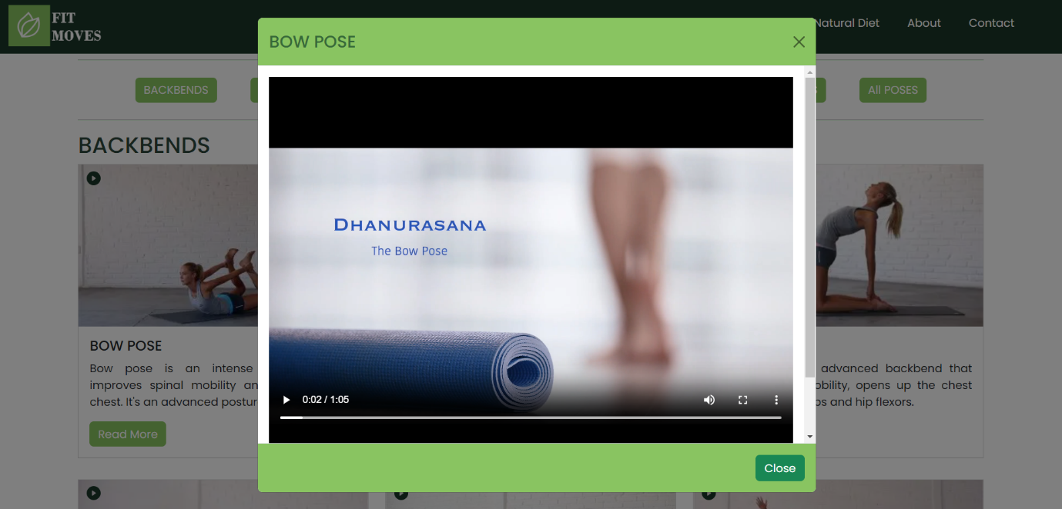

Pose by types includes a fixed navbar and a banner and then some button for filtering the category of the pose you want on one click and, in each category, there are few cards in which some description is written in the card and if you want more detail about the pose there is a button **Read more** click on it to see further detail and also a video icon on the image to see the detailed video of the pose that how to perform this pose.

**POSES BY BENEFITS**

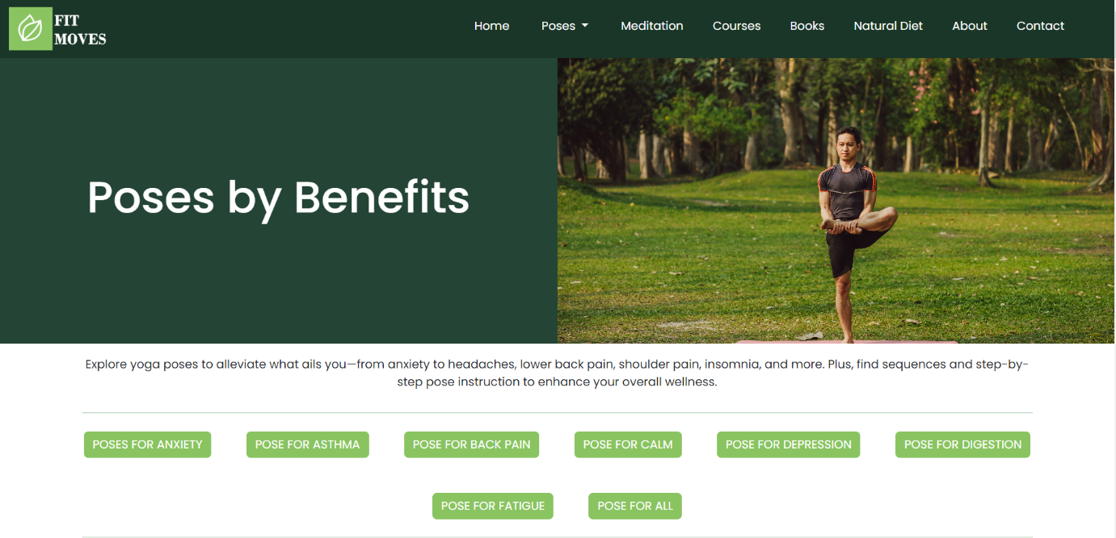

**POSES GENERAL**

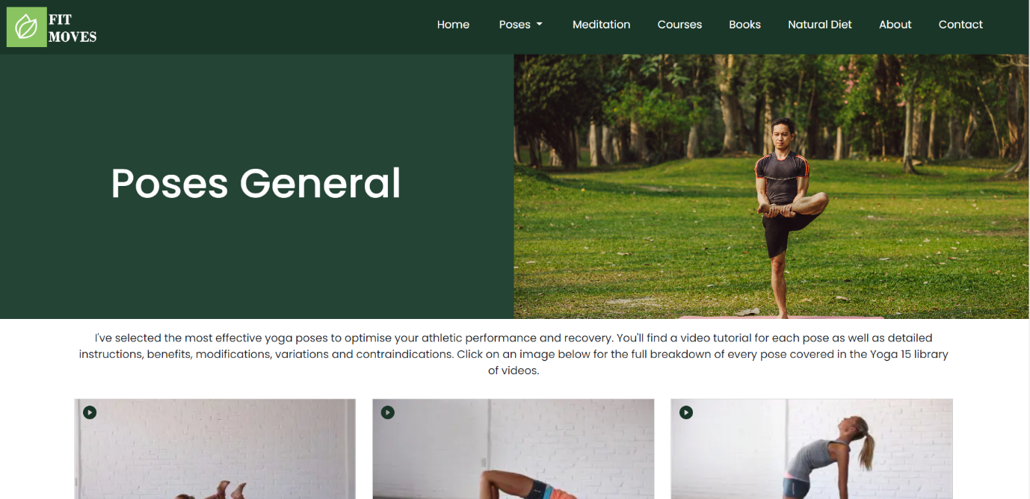

**POSES BY ANATOMY**

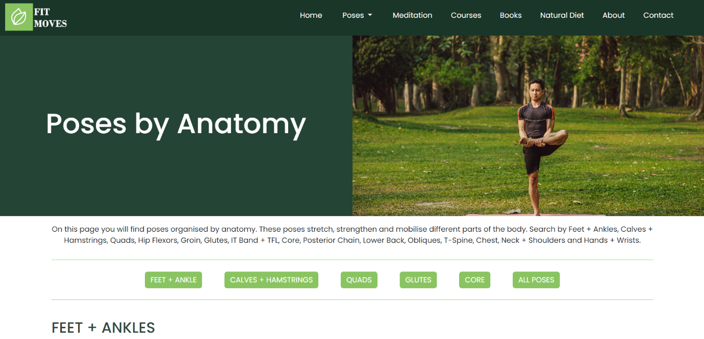

**Screenshots of Poses pages**

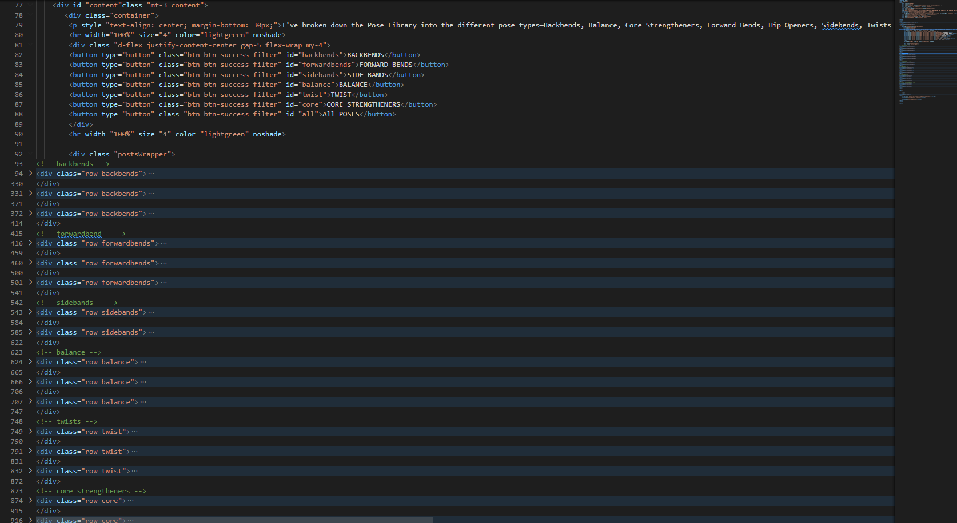

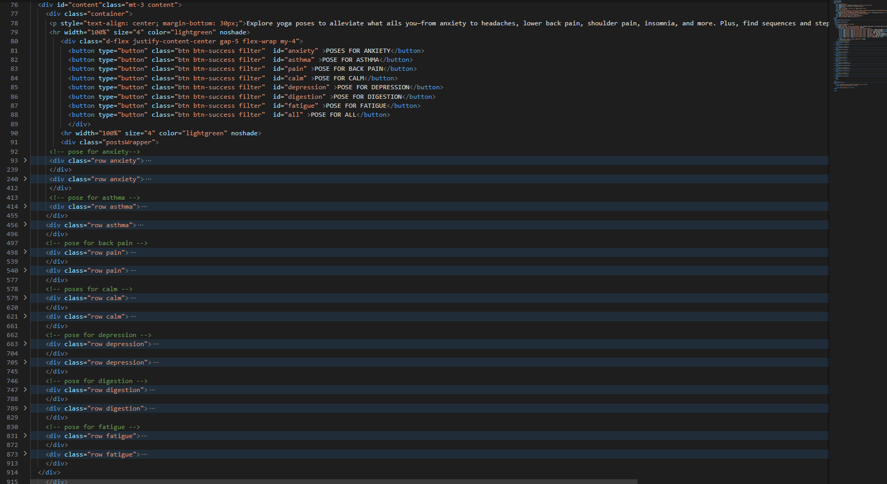

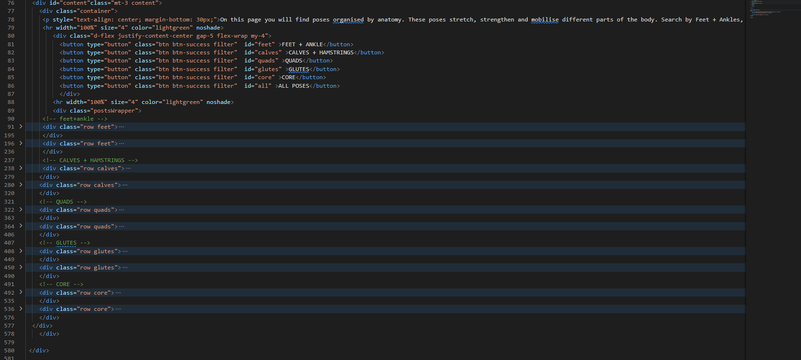

**CSS**

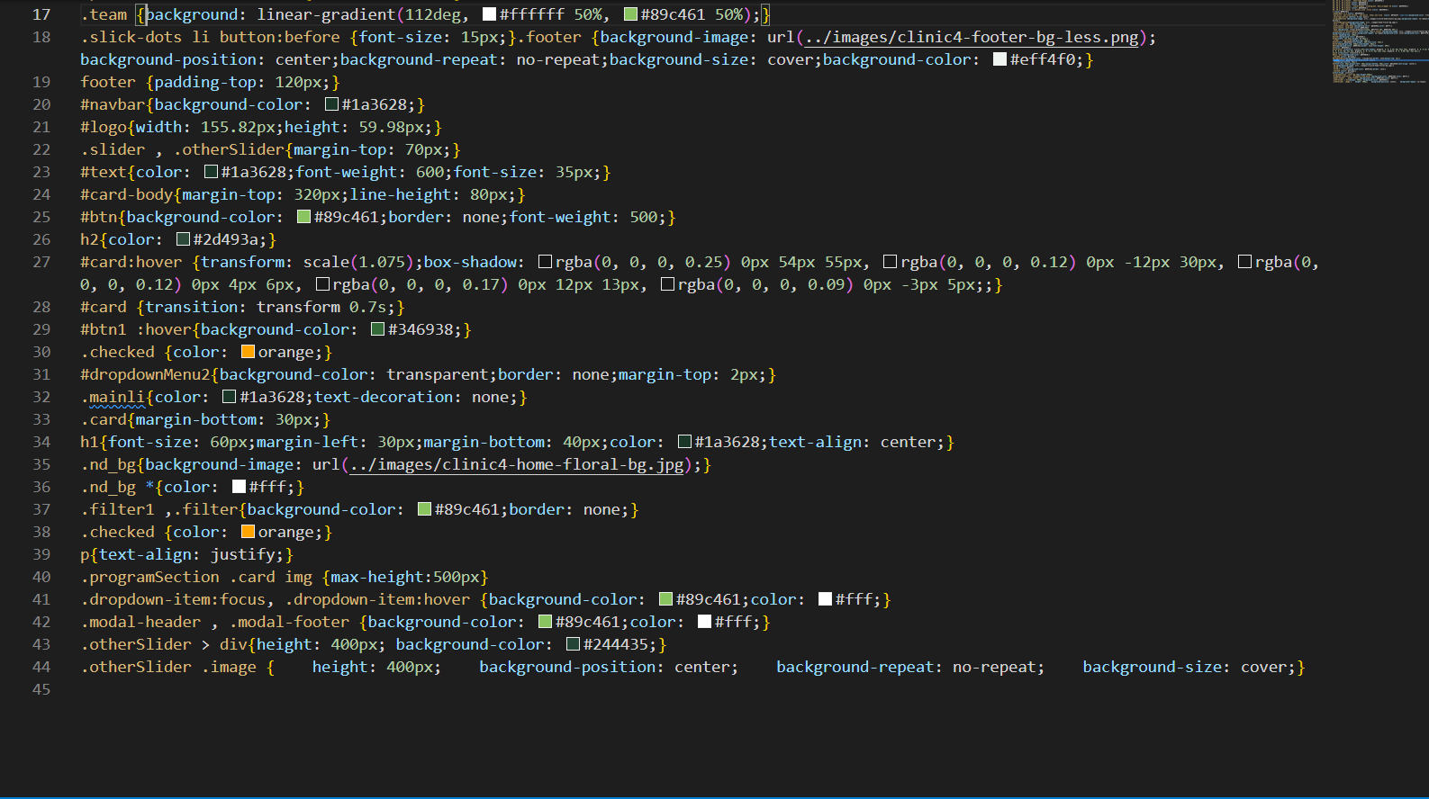

**JS**

